AUBURN UNIVERSITY

Senior Design
Cycle 1 Report
Group 1- Autonomous Helicopter

David Mason
Jens Johnson
Ed Budimier
Shaquana Peterson
Adam Gould

Table of Contents

- Summary-------------------------------------------------------------------------------------------------3
- Project Description (David Mason)

- Logistics--------------------------------------------------------------------------------------------------3
- System Structure (David Mason)
- Timeline (Ed Budimier)
- Budget (Shaq Peterson)
- Inventory and Components (Shaq Peterson)

- Testing and Prototyping History-----------------------------------------------------------------6
- Balance Report (Shaq Peterson)
- Arduino Fio Testing (Adam Gould)
- xBee Wireless Communications (Jens Johnson)
- Sharp IR range finder and remote control integration (David Mason)
- Testing and Prototyping the PING))) Ultrasonic Sensors (Ed Budimier)

- Testing and Prototyping Future-----------------------------------------------------------------18
  - Manipulating the Remote Control’s RF Transmitter (David Mason)
  - Control Logic Diagram (Jens Johnson)

Summary

Project Description
David Mason

Team 1, Project Autonomous Helicopter consists of five team members working together to develop an autonomous flight system for an RC helicopter.

In order to call the project a success, the following criteria should be met:
- Autonomous lift off and hover
- Autonomous landing
- Autonomous object avoidance exploration routine
- Autonomous wall following routine

Logistics

System Structure
David Mason

The hardware used to accomplish these goals consists of two Arduino Fio control boards each fitted with an xBee wireless communication module, four PING))) ultrasonic range sensors, two, light weight, lithium polymer batteries, and one RC helicopter with RF remote control. This system will use one Fio that is mounted to the helicopter along with all the sensors. The other Fio is controlling the remote control’s transmitter’s signal output. The first board will collect sensor readings and transmit that information, using the xBees, to the other board. The feedback will be analyzed to trigger the appropriate output signal setting which will control the actions of the helicopter.

Timeline
Edward Budimier

Below is the timeline with actual completion dates represented as of March 8th 2011; with future deadline dates.

Project Schedule
Activity | Cycle 1 |  |  |  | Cycle 2
Activity | 10FEB-16FEB | 17FEB-23FEB | 24FEB-2MAR | 3MAR-9MAR | 10MAR-16MAR |  | 17MAR-23MAR |  | 24MAR-30MAR | 31MAR-6APR | 7APR-13APR | 14APR-20APR
Wireless Communication
Balance Helicopter
Program Ultrasonic Sensors
Program IR Sensor
Repairs and ordering parts
Complete Prototype
Prototype testing
Complete Project
Milestones
1. Performance of sensors confirmed
2. Communication between microcontroller and helicopter controller confirmed
3. Developed a logic flowchart for helicopter's autonomous actions
4. Mounted Necessary parts onto helicopter and begin prototype testing
5. Helicopter tested to ensure proper autonomous function

Budget
Shaquana Peterson

Budgeting is very important in every financial plan. A good budget can help keep your spending under control and even leave room to put the extra money toward any other financial needs that may occur. So, with keeping the need for a good budget in mind, we first discussed our approach for the design of our project so that we could produce an effective budget. We then researched some of the same general parts and compared pricing on each item with the aim to come up with the cheapest, yet effective products. We decided to buy a commercially available helicopter rather than constructing our own, because we established that it will help to maintain a sufficient budget as well as create space for the amount of time needed for trial and error. We then constructed the table as shown below, which displays the cost of each product as well as the total estimated cost for the project.

Component | Supplier | Unit Cost | Quantity | Total Cost
3.5-Ch Metal Outdoor RC Helicopter Volitation 9053 | E Toys World | $68.25 | 1 | $68.25*
Arduino Fio | sparkfun.com | $24.95 | 2 | $49.90*
FTDI Basic Breakout | sparkfun.com | $14.95 | 1 | $13.95*
Main Rotor Blade Set A And B 4 | Superstition Hobbies | $8.24 | 1 | $8.24*
XBee 1mW Chip Antenna | sparkfun.com | $22.95 | 2 | $45.90*
Break Away Headers - Machine Pin | sparkfun.com | $2.95 | 1 | $2.95*
Polymer Lithium Ion Battery | sparkfun.com | $8.95 | 1 | $8.95*
Polymer Lithium Ion Battery - 20mAh | sparkfun.com | $5.95 | 1 | $5.95*
Triple Output LED RGB-Clear | sparkfun.com | 1.95 | 2 | $3.90*
Infrared Proximity Sensor Long Range | sparkfun.com | $14.95 | 1 | $14.95*
9V Snap Connector | sparkfun.com | $1.25 | 1 | $1.25*
9V to Barrel Jack Adapter | sparkfun.com | $2.95 | 1 | $2.95*
Arduino Uno SMD | sparkfun.com | $29.95 | 1 | $29.95*
Total Estimated Project Cost |  |  |  | $207.99*

*Note: Shipping and handling not included
Inventory and Components
Shaquana Peterson
Components | Description
3.5-Ch Metal Outdoor RC Helicopter Volitation 9053  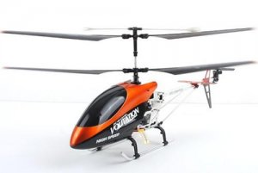 | Full function 3 channel radio control (Left /Right, Forward/Backward, Hover, and Lands)  Real life helicopter styling  3 channel digital proportional control  Built in Gyro for Extra Stability  Unique material withstand crashes  Flies over 100m high  2 powerful 180 main motors + N20 tail motor!
Updated Main Rotor Blade Set A And B 4 Pc 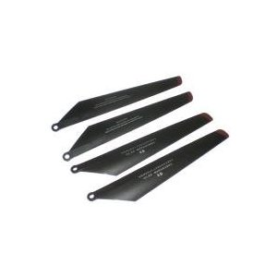 | Extra blades for RC helicopter
Arduino Fio  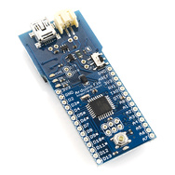 | Used sensor readings collection, and control signal generation.
FTDI Basic Breakout  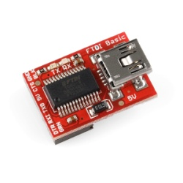 | Used to program the Arduino Fio through USB
Xbee 1mW Chip Antenna  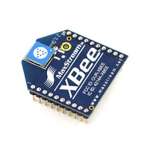 | Used to send sensor feedback from the microcontroller mounted on the helicopter.
Polymer Lithium Ion Battery - 900mAh  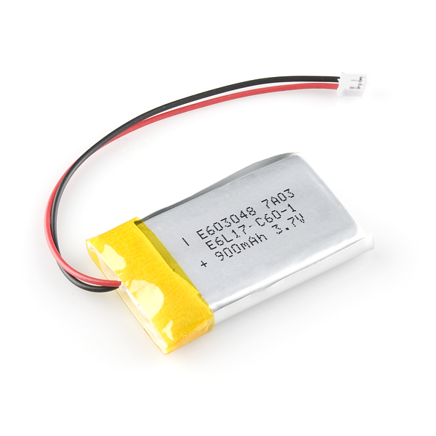 | Used to power the Arduino Fio on the Remote Control
Polymer Lithium Ion Battery-20mAh  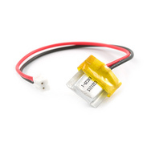 | Used to power the Arduino on the helicopter
Break Away Headers-Machine Pin  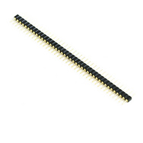 | This is a very large row of high quality machine pin headers - break to fit. 40 pins that can be cut to any size. Used to connect different components together
Triple Output LED RGB-Clear  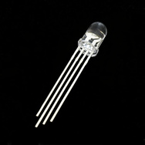 | Use this one LED for three status indicators or pulse width modulate all three and get mixed colors

Testing and Prototyping History

Balance Report
Shaquana Peterson

We want to attempt to configure the helicopter with all of the required components such as sensors, microcontroller, batteries, etc., while keeping the weight of the payload to a minimum. We tested the payload of the helicopter with simply a plastic bag, a homemade harness, and couple of rocks from which we gathered from outside. We then attached the plastic bag to the harness that was attached to the bottom of the helicopter and added one rock at a time. We then flew the helicopter to see if it would be able to carry the load. We repeated this procedure until we reached the maximum amount of rocks that the helicopter was able to hold while in flight. We reached the weight of about four medium sized rocks, in which we then concluded that the helicopter would be able to easily hold all of the components, because the weight of the rocks was much more than the weight of all of the components that we plan to attach to the helicopter. In order to attach the necessary components, we plan to use zipper tags or velcro so that we can move the sensors or components very easily if needed. For our sensor system, we plan to attach a sensor in the front of the helicopter to detect obstacles in its path, a sensor underneath the helicopter to control its elevation, and a sensor on both the right and left side of the helicopter to detect wall distance, parallelism, and wall following. Since we are adding items to the helicopter, we definitely want to make sure that the helicopter remains balanced. We plan to use the weight of the power supply to achieve an even amount of weight distribution, therefore helping the helicopter to maintain its balance.

Arduino Fio Testing
Adam Gould

To successfully create a helicopter that can fly autonomously, a micro-controller with the proper programming is essential. Team one resolved to purchase three separate micro-controllers for the design project. All three of the controllers are Arduinos. One of them is an Uno model and the other two are Fio models. To effectively use the micro-controllers it was first necessary to become familiar with the way that they function and the language that is used to program them. Basically this is what is entailed to be able to use the micro-controllers for our project.

All of testing that I accomplished was done using the Arduino Fios. The first step in learning to use the Fio was to become familiar with the pin locations and the function that each pin was designated for. Some of the functions include power, ground, inputs, outputs, and pulse width modulation. The next step was to connect the Fio to a computer.

To successfully connect the Fio to a computer an adapter is required. With the adapter installed correctly the Fio has the potential to be uploaded with programs from the computer. Before a program can actually be loaded onto the Fio it was necessary to download both the programming software and drivers for the Fio. Next step was to change several settings inside the programming software itself such as which port the micro-controller was being read from.

From there the next objective was to learn about and become proficient in using the programming language that the Fio operates with. This was done by studying several example programs that were provided on the Arduino website. After perusing several example codes it became apparent that the language that the Fio operates with is similar to the programming language C.

To become comfortable using the Fio I began to write simple codes to test the capabilities of the Fio. The first was simply to send out a high to a green led to make it light up. This was accomplished without too much difficulty. Then it was on to making the led blink at various intervals. After some level of comfort was achieved it was time to start coming up with code that more resembled what the program that would be controlling the helicopter would actually have to do.

One of the main objectives of the micro-controller program is to activate and run motors on the helicopter at various throttle levels. Not only that but be able to do this on multiple motors simultaneously. This is because the micro-controller will not be directly controlling motors on the helicopter but doing so indirectly through the helicopter remote control. To simulate this a program was written that will control a tri-color light emitting diode so that it is able to change to any color and is able to glow at any brightness setting between zero and it's max brightness. This program demonstrates control over timing, and voltage signal strength which is what is required for motor control on the helicopter. This is all accomplished by sending out three separate pulse width modulated waves to each of the three cathodes located inside the tri-color light emitting diode. The program is shown below.

*/
int ledPin = 9;
int ledPin2 = 10;
int ledPin3 = 11;
// LED connected to digital pin 9
// LED connected to digital pin 10
// LED connected to digital pin 11

void setup() {
// nothing happens in setup
}

void loop( ) {
// fade in from min to max in increments of 2 points:
for(int fadeValue = 0 ; fadeValue <= 235; fadeValue +=2) {
// sets the value (range from 0 to 255):
analogWrite(ledPin, fadeValue);
analogWrite(ledPin2, fadeValue);
analogWrite(ledPin3, fadeValue);
// wait for 50 milliseconds to see the dimming effect
delay(50);
}
}

When this type of program is set up to run a helicopter some problems arose. The micro-controller only was able set the motor on the helicopter to full speed, nothing in between full and zero. It is believed that the reason for this lies in that the micro-controller is putting out a digital signal into the helicopter remote control which needs an analog signal. The simple solution for this is to run the signal from the micro-controller through a digital to analog convert before it goes into the helicopter remote control. Further tests are being done to confirm this.

Once the micro-controller is successfully controlling the motor on the helicopter the next step is to create a closed loop control system. The system will be comprised of two Fios working in unison. One of the Fios will be mounted on the helicopter reading information from the sensors also mounted on the helicopter. The information from the sensors will then need to be transmitted to another Fio that is located on the ground attached to the helicopter remote control. That Fio will in turn take that information and interpret it to decide what the motors on the helicopter should do. That information will be translated into a signal that can be output through the remote’s RF transmitter to control the motors on the helicopter.

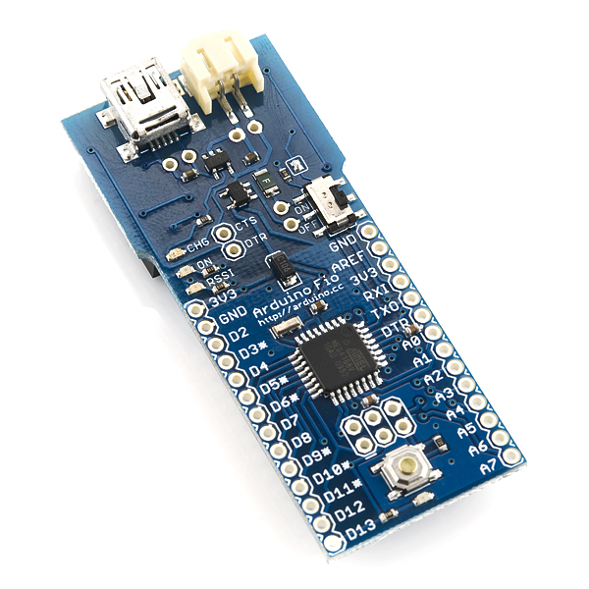
Microcontroller | ATmega328P
Operating Voltage | 3.3V
Input Voltage | 3.35 -12 V
Input Voltage for Charge | 3.7 - 7 V
Digital I/O Pins | 14 (of which 6 provide PWM output)
Analog Input Pins | 8
DC Current per I/O Pin | 40 mA
Flash Memory | 32 KB (of which 2 KB used by bootloader)
SRAM | 2 KB
EEPROM | 1 KB
Clock Speed | 8 MHz

To accomplish the task of sending information between the two Fios the team decided to buy two Xbee radios that are able to wirelessly load programs onto the Fio.

xBee Wireless Communications
Jens Johnson
The transceiver we are using is the 2.4GHz XBee module XB24-AWI-001 from Digi. These modules take the 802.15.4 stack and wrap it into a simple to use serial command set. These modules allow a very reliable and simple communication between microcontrollers, computers, and systems. Point to point and multi-point networks are also supported. Below are the included features of the transceiver taken from sparcfun.com.
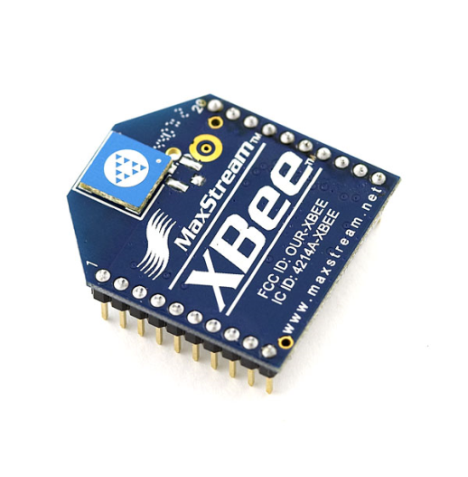Features:
- 3.3V @ 50mA
- 250kbps Max data rate
- 1mW output (+0dBm)
- 300ft (100m) range
- Built-in antenna
- Fully FCC certified
- 6 10-bit ADC input pins
- 8 digital IO pins
- 128-bit encryption
- Local or over-air configuration
- AT or API command set
The number one reason why we chose this module is due to the fact that it directly interfaces with the arduino FIO microcontrollers.
After obtaining the xBees it required significant research on the internet to figure out the process for using them. There were many tutorials and guides as to the steps to take in order to set up the transceivers, however, most of the time the authors of said tutorials and guides were not interfacing with the Arduino Fio microcontrollers. Also, the xBee that we purchased is the newer version and does not have some of the pins that were referred to online.
In the end, the Arduino website itself was the most useful in obtaining clear information on the operation of our precious components. The instructions were followed to the best of our understanding. However, some issues became apparent during the uploading of programs onto the boards and are currently being addressed.
To start, the xBee is placed on the shield, a set up code is initiated using the FioXBeeConfigTool interface. The interface is a GUI that configures the xBee to either be the programming radio or the fio controller radio.
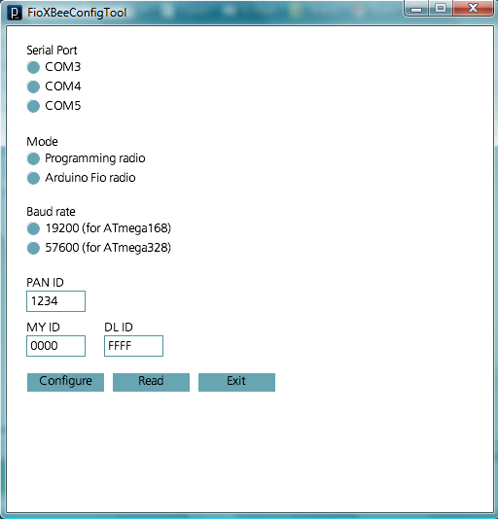
After establishing the communication priorities, a micro-controller can then be programmed to use the xBee to transfer data wirelessly to the other control board. Below is a sample script that demonstrates communication between two arduino control boards and their xBees. The sketch causes the built in LEDs to blink at regular intervals.

void setup()
{
Serial.begin(9600);
}

void loop()
{
Serial.print('H');
delay(1000);
Serial.print('L');
delay(1000);
}

This script was used to verify functionality of the transceivers. Something that still needs to be determined is how to send three variables (the data from all the sensors) back to the main controller. Sample codes have been referenced and it appears that we will be able to use the below as a foundation to meeting our transmission/communication needs.

/*
XBee sensor data graphing sketch

This sketch takes data in from an XBee radio and graphs the analog
input values. It's for XBee series 1 radios

Based on code from Rob Faludi and Daniel Shiffman

http://www.faludi.com

http://www.shiffman.net

created 2 Feb 2008
by Tom Igoe
*/

//import the xbee and serial libraries:
import xbee.*;
import processing.serial.*;

// Your Serial Port
Serial port;
// Your XBee Reader object
XBeeReader xbee;

// set up a font for displaying text:
PFont myFont;
int fontSize = 12;

// set up Xbee parameters:
int rssi = 0; // received signal strength
int address = 0; // sender's address
int[] analog = new int[6]; // values from the analog I/O pins
int[] previousValue = new int[6]; // previous values from the pins

int numSensors = 3; // number of sensors you actually plan to graph

int xpos = 0; // graph x position
int oldYPos = 0; // graph y position
int yPos = 0; // previous y position

int hitThreshold = 250; // peak value to check hits against
int hits = 0; // hit count
int lastHitValue = 0; // value of last hit

boolean newData = false; //whether or not you got a new reading

void setup() {
size(400, 300); // window size
frameRate(60); // frame rate
smooth(); // clean the jagged edges

// create a font with the third font available to the system:
myFont = createFont(PFont.list()[2], fontSize);
textFont(myFont);

// you might need a list of the serial ports to find yours:
println("Available serial ports:");
println(Serial.list());
// open the first serial port. Change this to match
// your serial port number in the list:
port = new Serial(this, Serial.list()[0], 115200);
// initialize the xbee object:
xbee = new XBeeReader(this,port);
xbee.startXBee();

// black screen:
background(0);
}

public void draw() {
// only draw when you have a new reading:
if (newData == true) {
// iterate over the number of sensors:
for (int thisSensor = 0; thisSensor < numSensors; thisSensor++) {
// if you have new data and it's valid (>0), graph it:
if (analog[thisSensor] > -1) {
// map the sensor values to the screen size for graphing:
yPos = int(map(analog[thisSensor], 0, 1023, 0, height));
oldYPos = int(map(previousValue[thisSensor], 0, 1023, 0, height));

// if we get a big change, increment the hit counter:
if (abs(yPos - oldYPos) >= hitThreshold) {
hits++;
// note the magnitude of the hit:
lastHitValue = abs(yPos - oldYPos);
}
}
// draw the graph axis:
stroke(255);
int xAxis = height/2;
line(0, xAxis, width, xAxis);

// use a different the graphing color for each axis:
switch (thisSensor) {
case 0:
stroke(255,0,0);
break;
case 1:
stroke(0,255,0);
break;
case 2:
stroke(0,0,255);
break;
}
// draw the graph line from last value to current:
line(xpos, oldYPos, xpos+1,yPos);
newData = false;

// write the text at the top
noStroke();
fill(0);
rect(0, 0, 300, 100);
fill(255);
text("From: " + hex(address), 10, 20);
text ("RSSI: " + rssi + " dBm", 10, 40);
text("X: " + analog[0] + " Y: " + analog[1] + " Z: " + analog[2], 10, 60);
text("Last hit value: " + lastHitValue, 10, 80);
}
// if you're at the right of the screen,
// clear and go back to the left:
if (xpos >= width) {
xpos = 0;
background(0);
}
else {
xpos++;
}
}
}
/*
This function works just like a "serialEvent()" and is
called for you when data is available to be read from your XBee radio.
*/

public void xBeeEvent(XBeeReader xbee) {
// Grab a frame of data
XBeeDataFrame data = xbee.getXBeeReading();

// This version of the library only works with IOPackets
// For ZNet radios, you would say XBeeDataFrame.ZNET_IOPACKET
if (data.getApiID() == XBeeDataFrame.SERIES1_IOPACKET) {

// Get the transmitter address
address = data.getAddress16();

// Get the RSSI reading in dBM
rssi = data.getRSSI();

// save previous state of analog values:
arraycopy(analog, previousValue);

// get the current values
// (-1 indicates channel is not configured):
analog = data.getAnalog();

// trip the new data flag so the draw() loop will graph:
newData = true;
}
else {
// it's not I/O data:
println("Not I/O data: " + data.getApiID());
}
}

Sharp IR range finder and remote control integration
David Mason

The Sharp infrared range finder is a good sensor for motion detection and distance approximation. It is light weight and easy to integrate into circuitry with only three pins: voltage in, ground, and signal. The signal output from the sensor is a range of mille-volts from twenty to five-hundred, which translates to centimeters as the range of the sensor is from twenty to one-hundred and fifty centimeters. So there is some math involved to find the actual distance. Otherwise, if precision is not needed the user can estimate using the 20 – 500 mV range.

In order to start prototyping, the Sharp range finder was used with the Arduino Uno which uses the ATmega328 surface-mount microcontroller. To demonstrate the IR range finder’s capabilities I constructed a circuit consisting of five LEDs, the IR range finder, the Uno, some resistors and a 9V battery. The five LEDs were used in a way that they would light up one by one depending on the distance being detected by the sensor. One super-bright LED was gradually brightened as the distance detected decreased and gradually fade as the distance increased. Once this was accomplished I began looking at the circuitry inside the hand held remote control for our test helicopter.

The main problem encountered during the testing of the E-Day helicopter was that the wrong pin was being manipulated by the microcontroller. Rather than generating a signal to be transmitted, attempts were made to recreate the current flowing through the circuits where the potentiometers were mounted. This resulted in uncontrollable signals being generated by the remote control. In future tests the signal being generated by the remote control and transmitted needs to be measured and recreated by the microcontroller.

The helicopter we are using is a three-channel model. This means the user has three axis of control. Those three axis are: altitude or main rotor throttle, forward and backward motion or rear rotor throttle, and heading or rotation control. Each of them uses a potentiometer to send a low voltage signal to be processed and sent through the IR or RF transmitter to the receiver that is built into the helicopter. By soldering a jumper wire to the ground and signal pins on the main rotor throttle, I was able to send a signal generated by the IR range finder to the remote’s transmitter. I was then able to turn on the helicopters main rotor blade by waving my hand in front of the IR range finder.

Code used to test the IR sensor and prototype lift off.

//Aurthor: David Mason
//Date: 2/22/11
//Senior Design IR Range with LED indicators.

int Throttle = 0; // Ascention and //Descention
int FRMag = 5;
int FRMag0 = 10; // How much to reverse the //helicopter
int FRMag1 = 15;
int FRMag2 = 20;
int IRpin = 1; // analog pin for reading //the IR sensor
int Sweet = 2;
int Green = 3;
int Short = 4;
int Long = 7;
int Detect = 0;
int Emmit = 3;
int Throttle = 11;

void setup() {
Serial.begin(9600); // start the serial port
pinMode(Green, OUTPUT);
pinMode(Sweet, OUTPUT);
pinMode(Short, OUTPUT);
pinMode(Long, OUTPUT);
pinMode(Detect, OUTPUT);
pinMode(Emmit, INPUT);
pinMode(Throttle, OUTPUT);

}
void loop() {
//IR RANGE FINDER
float volts = analogRead(IRpin)*0.0048828125; // value from sensor * (5/1024) - if running 3.3.volts then change 5 to 3.3
float distance = 65*pow(volts, -1.10); // worked out from graph 65 = theretical distance / (1/Volts)S - luckylarry.co.uk
float IRC = analogRead(Detect);
delay(100);
if (distance < 100 && distance >= 80){
digitalWrite(Short, HIGH);
digitalWrite(Sweet, LOW);
digitalWrite(Long, LOW);
analogWrite(Green, FRMag);
analogWrite(Throttle, 0.2);
}
if (distance < 80 && distance >= 60){
digitalWrite(Short, HIGH);
digitalWrite(Sweet, LOW);
digitalWrite(Long, LOW);
analogWrite(Green, FRMag0);
analogWrite(Throttle, 0.4);
}
if (distance < 60 && distance >=40){
digitalWrite(Short, HIGH);
digitalWrite(Sweet, LOW);
digitalWrite(Long, LOW);
analogWrite(Green, FRMag1);
analogWrite(Throttle, 0.6);
//analogWrite(Emmit, HIGH);
//analogRead(Detect);

}
if (distance < 40){
digitalWrite(Short, HIGH);
digitalWrite(Sweet, LOW);
digitalWrite(Long, LOW);
analogWrite(Green, FRMag2);
analogWrite(Throttle, 0.8);
}
if (distance >= 100) {
digitalWrite (Long, HIGH);
digitalWrite (Sweet, LOW);
digitalWrite (Short, LOW);
analogWrite(Green, LOW);
analogWrite(Throttle, 0);
}
//else {
// digitalWrite(Sweet, HIGH);
// digitalWrite(Long, HIGH);
// digitalWrite(Short, HIGH);
// analogWrite(Green, 1000);
// }
Serial.println("Dist ");
Serial.println(distance); // print the distance
Serial.println("Wireless ");
Serial.println(IRC);
//delay(1000); // arbitary wait time.
}

Testing and Prototyping the PING))) Ultrasonic Sensors
Edward Budimier

The sensor we will be using for forward and side detection is Parallax’s PING))) ultrasonic sensor. These sensors simply require a 5 Volt DC source pin and another to ground. Its third pin sends the results of sonar distance detection to our microcontroller to determine the helicopter’s surroundings. We will be using three of these sensors to detect the distances on the horizontal plane, as opposed to the one IR sensor used for determining the vertical height of the helicopter. Below are the features of the Ultrasonic Sensor.

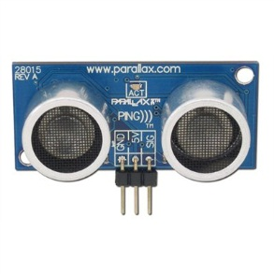Features:
- Precise to within a 2 cm to 3 m range
- Pulse in/pulse out communication
- Burst LED shows measurement in progress
- 20 mA power consumption
- 3-pin header

In order to write a program to utilize this sensor, the time it takes for one pulse to return must be used to calculate the distance being sensed. I also had to program using the Arduino software. Keeping this in mind, I looked to an example program for an ultrasonic sensor. I found an equation that translated my signal into correct distances from the sensor.

I took the basic example code that was provided, and modified it to do different actions at different distances. At first seeing if it was working, the different distance ranges turned on different LED’s. This showed me that these sensors can easily be used to act as interrupts in our helicopter’s main program, letting it know that it needs to watch out for walls or other obstacles. Below is the code I wrote for the single ultrasonic sensor.

//Ultrasonic sensor with use of LED's for proof of function

int pingPin = 2; //ultrasonic sensor signal pin on arduino controller
int near = 4; //LED pin used to show an object is very close
int closer = 7; //LED pin used to show an object has been observed getting closer
int far = 8; //LED pin used to show that no object is close by

void setup() {
// initialize serial communication:
Serial.begin(9600);
pinMode(near, OUTPUT);
pinMode(closer, OUTPUT);
pinMode(far, OUTPUT);
}

void loop()
{
// establish variables for duration of the ping,
// and the distance result in inches and centimeters:
long duration, inches, cm;
char warninga[] = " Danger Close"; //text output when an object is sensed very close by
char warningb[] = " Object Approaching"; //text output when an object is observed to be getting to be too close
char warningc[] = " Clear Path"; //text output when nothing is observed in a safe range

// The PING))) is triggered by a HIGH pulse of 2 or more microseconds.
// Give a short LOW pulse beforehand to ensure a clean HIGH pulse:
pinMode(pingPin, OUTPUT);
digitalWrite(pingPin, LOW);
delayMicroseconds(2);
digitalWrite(pingPin, HIGH);
delayMicroseconds(5);
digitalWrite(pingPin, LOW);

// The same pin is used to read the signal from the PING))): a HIGH
// pulse whose duration is the time (in microseconds) from the sending
// of the ping to the reception of its echo off of an object.
pinMode(pingPin, INPUT);
duration = pulseIn(pingPin, HIGH);

// convert the time into a distance
inches = microsecondsToInches(duration);
cm = microsecondsToCentimeters(duration);
//All of these serial.print commands give me a clean display of distance in inches and centimeters, and a warning depending the distance from the sensor
Serial.print(inches);
Serial.print("in, ");
Serial.print(cm);
Serial.print("cm");
if (inches <= 4){
Serial.print(warninga);
digitalWrite(near, HIGH);
digitalWrite(closer, HIGH);
digitalWrite(far, HIGH);
}
if (inches > 4 && inches <=8){
Serial.print(warningb);
digitalWrite(near, LOW);
digitalWrite(closer, HIGH);
digitalWrite(far, HIGH);
}
if (inches >8){
Serial.print(warningc);
digitalWrite(near, LOW);
digitalWrite(closer, LOW);
digitalWrite(far, HIGH);
}
Serial.println();

delay(100);
}

long microsecondsToInches(long microseconds)
{
// According to Parallax's datasheet for the PING))), there are
// 73.746 microseconds per inch (i.e. sound travels at 1130 feet per
// second). This gives the distance travelled by the ping, outbound
// and return, so we divide by 2 to get the distance of the obstacle.
// See: http://www.parallax.com/dl/docs/prod/acc/28015-PING-v1.3.pdf
return microseconds / 74 / 2;
}
long microsecondsToCentimeters(long microseconds)
{
// The speed of sound is 340 m/s or 29 microseconds per centimeter.
// The ping travels out and back, so to find the distance of the
// object we take half of the distance travelled.
return microseconds / 29 / 2;
}

Testing and Prototyping Future

Manipulating the Remote Control’s RF Transmitter
David Mason

The Double Horse 9053 RC helicopter is sold with a hand-held remote control with an RF transmitter to send commands to the helicopter while it is turned on and being operated. In order to make full use of the sensory system we are integrating with the helicopter, it is necessary to take the control of the transmitter unit out of the users hands and put it into the logic of a microcontroller.

Previous attempts to “plug” the Arduino Uno into the remote control failed to produce the desired effects on the helicopter. See the section titled “Sharp IR range finder and remote control integration.” Rather than using the potentiometers that are controlled by thumb sticks on the remote, the signal being sent to the RF transmitter needs to be analyzed and recreated. Once that signal can be recreated by the Fio, computer generated commands can be sent to the helicopter using the transmitter that is built into the remote control. Basically the entire remote control circuitry will be bypassed and the transmitter essentially be mounted to the Fio’s output.

The Fio mounted to the transmitter will be receiving sensor feedback, via the xBee wireless system, from the Fio mounted on the helicopter. When all the logic has been debugged, testing will begin to develop a take off and hover routine.

Control Logic Diagram
Jens Johnson

The idea behind the logic diagram is to provide some direction of what the overall code needs to accomplish as it executes. For reference purposes the image below depicts the sensors and their prospective positions on the helicopter. Each sensor is labeled S1-S4.

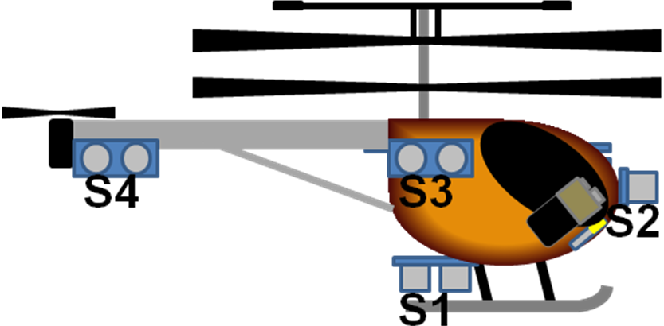

Below are three stages in the flight execution that will be looped and referenced to ensure correct system response. Firstly is the HOVER loop. In this loop S1 is the sole applicable sensor being used. S1 will determine how high off the ground the helicopter is. Once the sensor information is acquired it will be transmitted to our control board for analysis. Based on the results of the measurement the Helicopter will either increase or decrease lift.

Once a flight altitude is established, the helicopter can begin FORWARD movement. While in forward movement the system will passively be looping the hover command while looking for obstacles with S2. The Helicopter will continue to fly until S2 triggers an interrupt with its measurement.

At the onset of an obstacle the TURN command will execute. Turning will commence and will only stop when S3 and S4 are equal in value. This will ensure that the helicopter is going to fly parallel to the obstacle. And thusly will the autonomous flight continue.

In the diagram below the red arrows are logic 0, or no, and the green arrows are logic 1, or yes. The blue arrows are mandatory progressions. The dark blue boxes are subroutines, while the light blue boxes are logic inferences.

